Question: What is the policy related to failure to pay the premium?

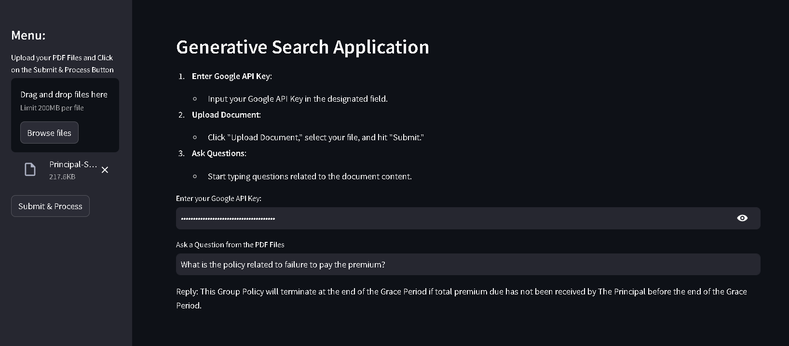

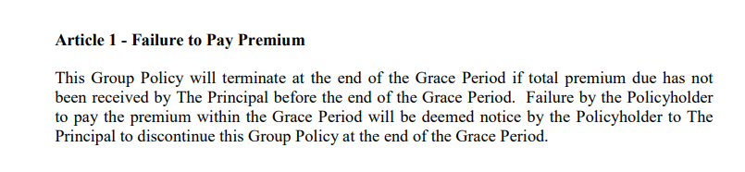

Question 2: What is the policy related to Termination Rights of the Policyholder?

